Conference Center
MARINA VILLAGE
CEREMONY SITE CONTRACT

CLIENT #: «assistant»

«first»«last»
CLIENT

CLIENT ADDRESS:
«address»
«city», «state» «zip»

«phone» «phone3»
TELEPHONE 1 TELEPHONE 2

«function_date»
DATE OF FUNCTION TIME OF FUNCTION

BRIDE / GROOM: «name»

Once CLIENT signs and returns this Ceremony Site Contract ("Contract") to SCPT Marina Village, LLC, a Delaware limited liability company ("CENTER"), along with the required event deposit specified below, CLIENT's reservation will be confirmed and considered a definite booking of the ________LAWN at Marina Village, 1936 Quivira Way, San Diego, CA 92109 (the "Lawn") at the cost of $600.00 (the "Fee") for the three (3) hour period specified above.

FEES & CHARGES

There is a $100.00 discount on the Fee for the use of the grounds for clients who have booked their reception with CENTER. The fee includes the use of an arch and 100 folding chairs. Folding chairs should not be used for people of exceptional weight or stature. Additional chairs must be procured from CENTER upon request at an additional fee. This Contract is for the period and location as defined herein, rain or shine. The CLIENT, CLIENT'S guests and vendors, may commence set up / decoration no earlier than the prescribed rental period commencement time and must complete their event and have all of their decorations, equipment, etc., removed from the site within the reserved time period. In the event of inclement weather on the day of the event, CENTER will make every effort to make available another location at CENTER for the ceremony; provided, however, CENTER does not warrant or guarantee the availability of an alternative site. If an alternative site is located, there will be an additional $100.00 set up fee for this alternate site.

CLIENT agrees to rent from CENTER the following additional equipment for the fees listed in Exhibit "A".

CLIENT will be responsible for the expense of any labor required by CENTER personnel to clean the grounds following the event at a charge of $40.00 per labor hour. Any charges outlined below (i.e. removal of trash, confetti, etc.) will be in addition to the $40.00 per hour labor rate.

The use of confetti or rice or bird seed is prohibited on the grounds. If this occurs, there will be an additional charge in the amount of $50.00.

There will be a charge of $10.00 per bag of trash not disposed of by CLIENT.

EVENT DEPOSIT

An event deposit, equal to fifty percent (50%) of the Fee, is required to be paid by CLIENT, as initial payment at the time the signed Contract is delivered to CENTER in order to reserve a ceremony site. The remaining portion of the Fee and any additional charges will become due and payable no later than sixty (60) calendar days prior to the event. Failure to provide the balance of the Fee is considered an automatic cancellation by CLIENT.

CANCELLATION POLICY / AMENDMENTS

In the event the CLIENT should cancel this Contract within seventy-two (72) hours of signing the Contract, CLIENT agrees to pay CENTER one hundred dollars ($100.00) administration fee, to be deducted from the CLIENT's deposit. In the event CENTER cancels the Contract within the first seventy-two (72) hours, then the CLIENT's deposit will be fully refunded. Should either party cancel this event after seventy-two (72) hours following execution of this Contract, liquidated damages shall be paid by the canceling party to the non-canceling party at the time of the cancellation. This amount is agreed not to constitute a penalty. Payment due as a result of cancellation of the Contract under this provision shall be made by the canceling party to the non-canceling party at the time the Contract is canceled by written notice in accordance with the following schedule: 1) cancellation date is ninety (90) days or more calendar days prior to the date of the function, 25% of the total Lawn rental charges; 2) cancellation date less than ninety (90) calendar days but greater than sixty (60) calendar days from the date of the function, 50% of the total Lawn rental charges; 3) cancellation sixty (60) calendar days or less prior to the date of the function, 100% of the total Lawn rental charges. If the CLIENT requests to change the date location of their event, CENTER at its sole discretion can approve or disapprove such change. If CENTER can't accommodate CLIENT with the change request, CLIENT then must comply with the terms and conditions of this Contract. If the CENTER can accommodate the change, the charges will be increased accordingly, but in no case will the charges be reduced or the due dates delayed for pre-payment of deposits. In the event an earlier date is accepted, then the due dates for deposits will be accelerated to match the earlier due date. Failure to pay deposits on time will result in CLIENT default and this default results in automatic cancellation of the event, subject to liquidated damages payable by CLIENT to CENTER as defined in this Contract.

CENTER reserves the right to cancel this Contract at any time, with or without notice, in the event that any term, condition or promise in this Contract has been or is being violated. In such event, there will be no reimbursement or credit towards any fee previously paid or any fee still owing. If the CENTER brings any action to enforce any of the terms, conditions or promises in this Contract, it shall be entitled to its reasonable attorney's fees incurred in such an action.

All changes to the Contract or cancellations must be in writing (letter or facsimile) and signed by CLIENT or their authorized agent; provided, however, that the requirement that cancellations be in writing does not apply in the case of CLIENT's failure to make deposits on time. Changes are not an amendment to this Contract unless signed by the CENTER's agent.

TERMS & CONDITIONS

By execution of this Contract and conducting the event, CLIENT shall be deemed to have accepted the Lawn in an "as is" condition and as being in good and acceptable order, condition and repair.

CLIENT represents that the event will be hosted by CLIENT. CLIENT shall have no right to assign this Contract without CENTER's prior written consent which may be withheld at CENTER's sole option. CLIENT represents that the event will be a private event and will not be open to the public. CLIENT represents that he/she is not representing, either partially or wholly, a fraternity or sorority of a college or university (defined as 5 or more attendees who belong to a fraternity or sorority). CLIENT represents that all guests are known by CLIENT and that open invitations to unknown or non-affiliated invitees will not be issued. If the event is associated with a club, company, team, etc., the club, company, team, etc. have been named on the application. In the event that CLIENT misrepresents the purpose of party or event, violates the provisions of this paragraph, CENTER has the unilateral right to cancel / terminate the event and CLIENT would be the liable party for cancellation fees as provided in this Contract. If the event is canceled within seven (7) calendar days of or during the event for failure to comply with the conditions of this agreement, CLIENT agrees that CENTER will have earned the entire fee, including additional rental items in Exhibit "A" as updated prior to the event by CLIENT, otherwise due for use of the Event Room and equipment.

CLIENT acknowledges and agrees that (i) there are a number of rooms at Marina Village at which events are hosted and, as a result, there may be other events that occur at the same time as the event that CLIENT is hosting and CENTER is not responsible for the actions of the invitees at such events, (ii) CLIENT's guests will be restricted to participation in CLIENT's event and shall not be entitled to participate in any other events that may occur during CLIENT's event in another portion of CENTER, (iii) not all buildings and grounds of CENTER are accessible to disabled persons, (iv) that CENTER shall bear no responsibility for ensuring that its buildings and grounds are accessible to disabled persons, (v) access to the marina itself is not restricted by a fence, and (vi) CLIENT assumes all risk of loss associated with walking on the lawns and using folding chairs placed on grass grounds that aren't level surfaces.

Neither CENTER nor CENTER's managers, officers, directors, shareholders, trustees, principals, employees, agents, contractors, predecessors, successors and/or assigns (whether disclosed or undisclosed) (collectively referred to herein as the "CENTER PARTIES") shall be liable to CLIENT or to CLIENT's guests, invitees, licensees, agents, employees and/or independent contractors (collectively referred to herein as the "INVITEES"), for any losses, liabilities, obligations, claims, damages, expenses, costs (including without limitation attorneys' fees), penalties or fines (collectively referred to herein as "DAMAGES") incurred in connection with or arising from the fact that any buildings and/or the grounds at CENTER are not accessible to disabled persons and/or the fact that access to the marina is not controlled.

ACCESS & INDEMNITY

CLIENT acknowledges that Marina Village is located on parklands with full public access. CLIENT takes full responsibility for crowd control.

CLIENT acknowledges being informed, and shall assume full responsibility for informing its INVITEES who may have a need for such information, that restrooms that are accessible to disabled persons are located in the area identified on Exhibit "B" attached hereto. CLIENT agrees to inspect the Event Room prior to or within 72 hours of signing this Contract to ensure suitability of the Event Room for the planned event and the anticipated guests or supporting equipment. CLIENT is advised that the second story rooms and seating areas are not serviced by elevators and some of the rooms require the use of public restroom facilities. CLIENT acknowledges that access to the docks and gangway to the docks is restricted and that its Invitees shall not be granted access to this portion of Marina Village during the event.

CLIENT hereby agrees to indemnify, defend, and hold harmless CENTER and the CENTER PARTIES from and against any and all DAMAGES arising from (a) the use of any room and/or the grounds of Marina Village by CLIENT and/or the INVITEES, or (b) from CLIENT's activities or the activities of the INVITEES in any room and/or on the grounds of Marina Village, including in the waters of the marina, or (c) from anything done, permitted or suffered by CLIENT or the INVITEES in any room or on the grounds of Marina Village, or (d) from CLIENT's failure to observe or perform any agreement or promise under this Contract. This indemnity obligation shall survive the termination of the Contract.

CLIENT agrees to be responsible for any damage done by the CLIENT, the INVITEES, or other agents under the CLIENT's control. The CENTER will not assume or accept responsibility for conditions beyond the control of the CENTER or damage to or loss of any merchandise or articles left in the room prior to, during, or following the CLIENT's function.

CENTER provides on-site staff and, reserves the right to provide additional security personnel. CLIENT acknowledges that CENTER is under no obligation to provide security personnel for the event and CENTER shall have no liability hereunder if CENTER does not elect to provide security personnel. If CLIENT wishes to engage additional security personnel, CENTER reserves the right to specify the firm engaged for this purpose. In the event CLIENT requires assistance during its event, CLIENT agrees to notify the staff or security personnel of their specific needs so they can be addressed as soon as possible. CLIENT understands that unless prior arrangements are made, however, there can be no assurance that CENTER will be staffed to provide such assistance. If CLIENT, in their judgment, feels that additional dedicated security will be necessary to control access to their event or assist with the execution of their event, CLIENT should contact CENTER to request such additional services, and CENTER will make arrangements assign appropriate personnel to their event. CLIENT shall be responsible for the cost of such personnel and shall reimburse CENTER therefore at CENTER's current cost. CLIENT will be responsible for providing CENTER with written instructions for specific security requirements.

In event of an emergency that requires fire, police or emergency medical personnel, CLIENT agrees to call 911 immediately. In these cases, CENTER would act in the same manner and the emergency response may be unduly delayed if CLIENT delays. CENTER's security personnel are not trained or qualified to administer emergency services. On-Site staff may be located at the office during business hours (619-222-1620) or after hours at (619) 666-5418 (primary) or (619) 778-6415 (secondary).

CLIENT agrees that the event shall be of first class quality consistent with the image of Marina Village. For events where a significant portion of the attendees are expected to by under 21-years-of-age, CENTER shall enforce an appropriate dress code. CENTER shall have sole discretion to determine what constitutes proper attire. Attendees who do not comply with the dress code after being requested to do so, will be asked to leave the premises. If it appears uninvited guests are a problem, a responsible family member or representative of CLIENT shall assist security personnel in identifying bona fide guests, when requested to do so.

If CENTER is required to bring any action to enforce any of the terms, conditions or promises in this Contract, CENTER shall be entitled to reimbursement for its reasonable attorney's fees incurred in such an action.

SUMMARY OF CHARGES

TOTAL LAWN CHARGE: $
RENTAL CHARGES: $To Be Determined
OTHER/ADD'L CHARGES: $0.00
TOTAL CHARGE: $
LESS INITIAL PAYMENT: $ Due with signed contract
BALANCE DUE: $ Due by: _________________

It is understood by CLIENT that this Contract is tentative and not binding until the initial payment of the event deposit and this signed Contract is received and countersigned by CENTER's representative. Continued availability of the Lawn is subject to receipt of an executed copy of the Contract and the deposit.

CLIENT:

_______________________________________
Signature

_______________________________________ Date: ________________
Print Name

CENTER:

SCPT Marina Village, LLC (a Delaware limited liability company)
By: CHM Hotels Inc., its Property Manager

By: ________________________________________ _________________ Date
Title: ______________________________________
EXHIBIT “A”
Rental Items, Cleaning Waiver and Instructions
Rental Items
Linens $8.00 each
 | White or Ivory:_______________ |  |  | Quantity:__________ |  | Total:_____________
Napkins $0.50 each
 | White or Ivory:_______________ |  |  | Quantity:__________ |  | Total:_____________
White Wood Chairs (Ceremony) $2.25 each |  |  |  | Quantity:__________ |  | Total:_____________
Change/Prep Room $100.00 each |  |  |  | Quantity:__________ |  | Total:_____________
Belly Bar $10.00 each |  |  |  | Quantity:__________ |  | Total:_____________
Banquet Chairs $3.50 each |  |  |  | Quantity:__________ |  | Total:_____________
1/2 Moon Table $10.00 each |  |  |  | Quantity:__________ |  | Total:_____________
High Chairs $10.00 each |  |  |  | Quantity:__________ |  | Total:_____________
Screen $35.00 each |  |  |  | Quantity:__________ |  | Total:_____________
Sound System $125.00 each |  |  |  | Quantity:__________ |  | Total:_____________
LCD Projector $250.00 each |  |  |  | Quantity:__________ |  | Total:_____________
Risers (4'x4' section) $30.00 each |  |  |  | Quantity:__________ |  | Total:_____________
 |  |  |  |  |  | Total:_____________

EXHIBIT “A”
Rental Items, Cleaning Waiver and Instructions

Cleaning Waiver and Instructions

When the Marina Village Staff cleans the room following your party, their duties are to break down the tables and chairs, and vacuum/mop. Any refuse that is left by your party that cannot be vacuumed will be cleaned up by our staff at the stated rate of $40.00 per man, per hour, and also at $10.00 per bag of trash. The list of items that our staff will consider in their cleaning includes, but is not limited to:

Decorations: Any decorations left behind (including, but not limited to, balloons, streamers, & centerpieces) will be considered trash, and will be bagged with other trash at $10.00 per bag.
Rental Furniture: We require that any rental furniture or items not provided by Marina Village be removed by the time the last person leaves for the evening. We will not hold items for pick up the next day, including but not limited to chairs, tables, arches, etc, and will instead consider them in our cleaning charges ($40.00/man/hour).
Trash: Any further refuse that cannot be vacuumed will be put into bags and removed by our staff. There is a $10.00 charge for each bag of trash removed by our staff.
Carpet Damage: Any costs related to removing stains or damage due to burns will be charged back to the client. These charges will include costs for cleaning and repair by outside vendors and/or labor by Marina Village Staff.

Property Damage: Any Marina Village property, which is broken during your party, will be subject to repair at the sole cost to the client.

As long as you attend to the above consideration on the same day as your party, you should receive a full return on your entire damage deposit.

Dumpsters: Locations of the dumpsters are marked on the map below by the 'X'. Please put all of your trash in the dumpsters.

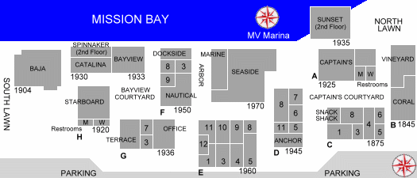

X

X

X X
X

EXHIBIT “B”
ADA Compliant Restroom Locations

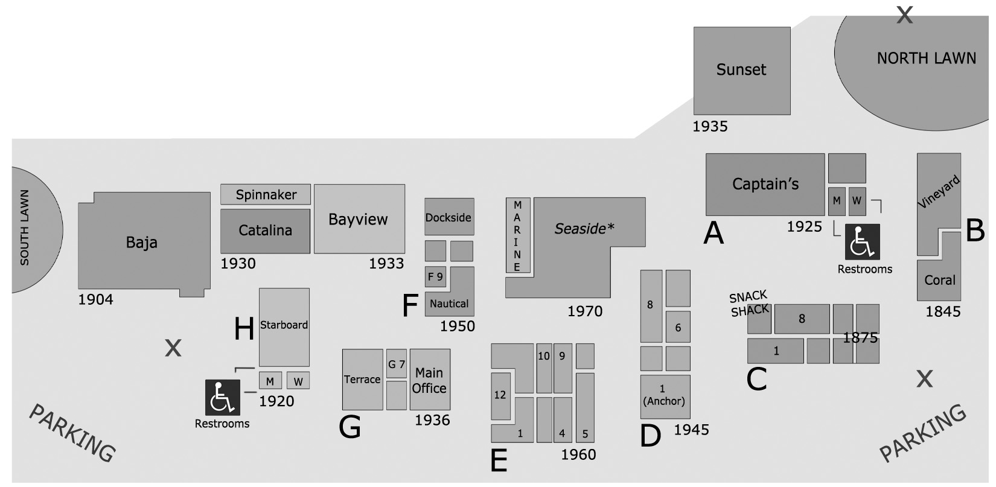

X

